Project Design Phase-II
Technology Stack (Architecture & Stack)
Date | 02 February 2026
Team ID | LTVIP2026TMIDS60803
Project Name | Optimizing User, Group & Role Management with Access Control and Workflows
Maximum Marks | 4 Marks

Technical Architecture:
The Deliverable shall include the architectural diagram as below and the information as per the table1 & table 2 Example: Optimizing User, Group & Role Management with Access Control and Workflows
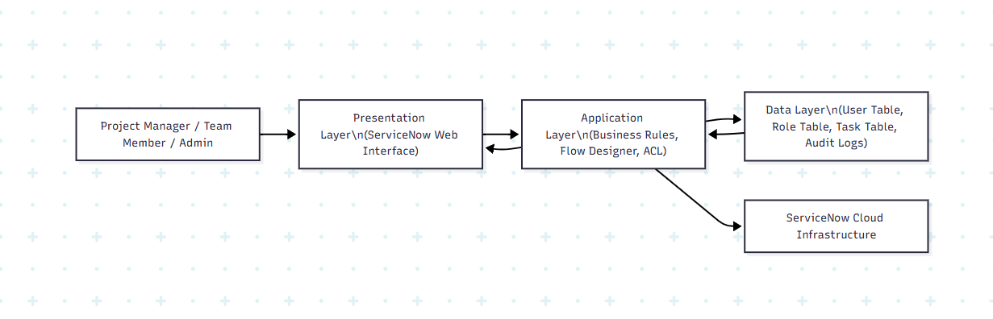
Reference: https://developer.ibm.com/patterns/ai-powered-backend-system-for-order-processing-during-pandemics/
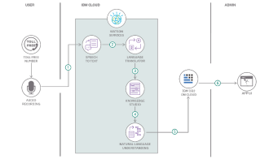
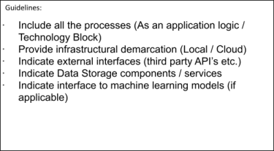
Table-1 : Components & Technologies:
S.No | Component | Description | Technology
1 | User Interface | Web-based dashboard for managing users, roles, and tasks | ServiceNow Web UI (HTML, CSS, JavaScript)
2 | Application Logic-1 | User & Role Management Logic | ServiceNow Business Rules, Glide API
3 | Application Logic-2 | Task Workflow Automation | ServiceNow Flow Designer
4 | Application Logic-3 | Access Control & Permission Management | ServiceNow ACL (Role-Based Access Control)
5 | Database | Stores users, roles, groups, tasks, and logs | ServiceNow Relational Database (MySQL-based backend)
6 | Cloud Database | Managed cloud-based database service | ServiceNow Cloud Data Storage
7 | File Storage | Stores attachments related to tasks | ServiceNow Attachment Storage
8 | External API-1 | Email notification integration | SMTP / Email Notification Service
9 | External API-2 | Integration with third-party tools (optional) | REST APIs
10 | Machine Learning Model | Task categorization & predictive insights (optional feature) | ServiceNow Predictive Intelligence
11 | Infrastructure (Server / Cloud) | Cloud-based SaaS deployment model | ServiceNow Cloud Infrastructure

Table-2: Application Characteristics
S.No | Characteristics | Description | Technology
1 | Open-Source Frameworks | Uses standard web technologies and REST integration | JavaScript, REST API
2 | Security Implementations | Role-Based Access Control, encrypted communication, login authentication | ServiceNow ACL, RBAC, HTTPS (SSL/TLS), IAM Controls
3 | Scalable Architecture | Multi-tenant SaaS architecture supporting increasing users & projects | ServiceNow Cloud Platform
4 | Availability | 24/7 cloud-based availability with redundancy and backup | ServiceNow Data Centers & Load Balancing
5 | Performance | Optimized database indexing, caching, workflow optimization for faster processing | ServiceNow Glide Engine & Indexed Tables

References:
https://c4model.com/
https://developer.ibm.com/patterns/online-order-processing-system-during-pandemic/
https://www.ibm.com/cloud/architecture
https://aws.amazon.com/architecture
https://medium.com/the-internal-startup/how-to-draw-useful-technical-architecture-diagrams-2d20c9fda90d

